The Future of Work:   
Productivity in a Remote-First World

#### Prepared for:

#### Brent Shafer, Chairman & CEO of Cerner Corporation

#### Prepared by:

#### Aaron Simpson, VP of Engineering

#### 

#### 

#### 

#### November 22, 2020

**To:** Aaron Simpson, VP of Engineering

**From:** Brent Shafer, Chairman, CEO of Cerner Corporation

**Date:** November 11, 2020

**Subject:** Commissioning report on productivity and the effects of remote work adoption

Amidst the COVID-19 pandemic and the forced shift to remote work, more discussions are being had about the effect on worker productivity, and what impact this could have on how firms operate moving forward. We would like to better understand how Cerner employees, particularly Cerner engineers, are feeling about the shift, and whether the adoption of permanent work-from-home accommodations could be effective.

The executive board is requesting a formal report analyzing this issue to help guide our organization into the future. We would like to get a solid sense of academic research on the subject, as well as opinions across various publications in the business, management, and strategy sector. Prime questions are what effect this would have on rates of worker productivity; potential health impacts of increased sitting time and social isolation; and how team leaders can best prepare themselves for leading remote teams.

Success in business is given to those who are prepared and can adapt the fastest. To ensure timely response and organizational agility, as well as preparedness for the next fiscal quarter, we would prefer to receive your report by December 2nd, 2020.

We look forward to receiving your report to help improve Cerner Corporation and keep our position as one of the top healthcare technology providers in the world. If you have any questions or concerns, please contact Will Mintz at 555-645-2806 or willmintz@cerner.com.

**To:** Brent Shafer, Chairman, CEO of Cerner Corporation

**From:** Aaron Simpson, VP of Engineering

**Date:** November 22, 2020

**Subject:** Completed report on productivity and the effects of remote work adoption

The following report is a response to your request on the effects of remote work on rates of productivity; potential adverse impacts on employee health; and tips for team leaders on managing remote teams.

From the research, it seems clear that the adoption of work-from-home accommodations can lead to positive benefits, contingent on several factors:

* the nature of the work being performed,
* personality traits and preparedness of workers and managers, and
* negating the adverse health impacts of sitting, like encouraging breaks and investing in accommodations like adjustable desks.

We are sure that the following report will help Cerner Corporation evolve into a 21st-century organization, attracting the best talent and helping deliver quality healthcare services to millions around the world.

I would like to thank Chief Strategy Officer Will Mintz for his assistance and consultation on these matters, as well as the executive board for the opportunity to perform this analysis. If you have any questions, comments, or concerns, please feel free to reach out by phone at 555-820-5210 or email at aaronsimpson@cerner.com.

**Table of Contents**

Memo of Authorization…………………………………………………………………………...ii

Memo of Transmittal……………………………………………………………………………..iii

Executive Summary………………………………………………………………………………iv

Introduction………………………………………………………………………………………..1

Mode of Analysis………………………………………………………………………………….2

Analysis of Worker Productivity………………………………………………………………….3

Analysis of Health Impacts………………………………………………………………………..5

Analysis of Management………………………………………………………………………….7

Conclusion………………………………………………………………………………………...8

Recommendations………………………………………………………………………………..10

References………………………………………………………………………………………..11

**List of Figures**

Figure 1: US Unemployment Rate Oct. 2019 – Oct. 2020

Figure 2: What, if anything, about remote work at your organization has worked poorly

**List of Tables**

Table 1: Share of jobs that can be done at home, by occupation’s major group

**Executive Summary**

The COVID-19 pandemic has caused a shift in the way work is performed, leading to questions about the future of work and what organizations could look like moving forward.

As a player in the competitive industry of healthcare information technology, it is imperative that Cerner remains on top of new developments in business strategy and management. The Cerner executive board requested a summary of research on the above topics, hoping to arrive at conclusions on if and how to most effectively implement a remote work accommodation package.

We analyzed the emerging field of research on productivity in remote environments, as well as the consensus among medical researchers on the negative impacts of sitting, and the growing epidemic of mental health problems in adults. We also reviewed renowned business publications for their thoughts on management strategy and how to effectively lead hybrid or fully remote teams.

Through our research, we arrived at the following conclusions:

* Remote work productivity is a highly individual metric, relying on variables like living environment, previous experience with remote work, team communication strategy, personal self-discipline, and important demographics like gender and marital status.
* The negative effects of prolonged sitting on diabetes risk and cardiovascular health are well-established. However, there is also established research that interventions like sit-stand desks and encouraging breaks are effective in reducing sitting time and protecting worker health. Like productivity, the effects of remote work on worker mental health are individual, dependent on organizational habits, openness to new experiences, introversion, and other characteristics.
* Remote work adoption is only going to accelerate, so it is imperative that managers invest in the skills for managing these kinds of employees. The lack of in-person communication means that social bonds are far more difficult to build and maintain. Remedies are a consideration for worker experience from the top down of the company; leveraging multiple channels like text, Slack, email, and more; and increased effort in showing care for employee problems and acknowledgement of their concerns.

Our research leads us to recommend the following:

* Make optional work-from-home accommodations available for software engineers, IT support, and HR personnel.
* Offer remote employees ergonomic options like sit-stand desks and encourage short breaks every 30 minutes.
* Offer childcare benefits for employees with young children.
* Train managers in handling remote teams by encouraging regular meetings with employees working from home, and fostering a culture of open communication and care for worker experience

**Introduction**

Global pandemics are of significant concern to both the public and private sector. Governments seek to protect their citizens and healthcare infrastructure by stemming the spread of disease through encouraging frequent handwashing, social distancing, and mask measures. However, they must also weigh these decisions against the associated economic impacts. Private companies seek to remain stable and profitable even during times of societal unrest, working to ensure employee and customer health to comply with local regulations and deliver quality products and services.

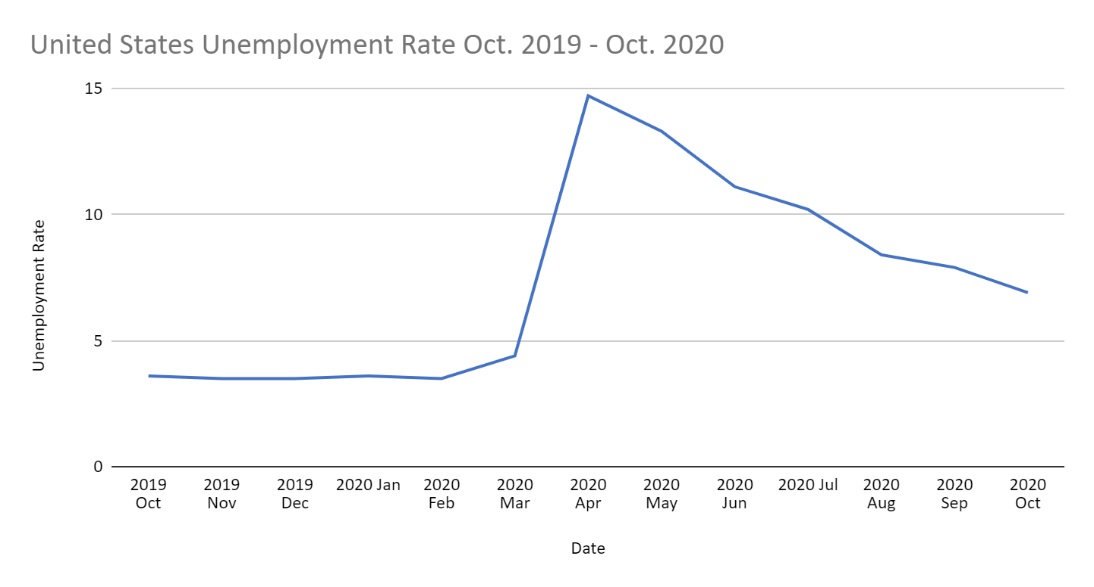The COVID-19 pandemic is shaping to be one of the largest public health crises of the 21st-century. GDP of developed nations has plummeted, entire economic sectors have been devastated, and over 1 million globally have died **(source)**. Furthermore, even those sectors spared by the economic impacts have undergone radical shifts and reorganization, converting from in-person operation to majority remote. According to the Bureau of Labor Statistics, at the height of the pandemic, approximately 35% of workers had worked from home at some point in the past month due to COVID **(source)**. However, despite rising case numbers in the United States, hopes for a quick vaccine are high after successful trials from pharmaceutical corporations like Pfizer and Moderna **(source)**.

This radical shift in the way we work has many - especially in sectors like high technology - asking questions about remote work and the future of employment. Remote work offers the benefit of geographic flexibility, allowing workers to avoid high cost-of-living (CoL) areas like California and New York. It also eliminates commuting, lowering the number of cars on the road, decreasing congestion, and saving on carbon emissions that harm the environment. Transport accounts for around 26% of total energy demand in the United States, and work-from-home has the potential to reduce total car usage substantially **(source).** Others however are skeptical about these benefits, raising concerns about lowered productivity i.e. “slacking”; physical and mental health impacts from prolonged sitting and isolation; and difficulties for team leaders managing asynchronous teams.

As a company at the forefront of its industry, Cerner has a vested interest in attracting and retaining the best talent. Our hope is this report will assist in keeping Cerner abreast of the latest trends in business, helping to beat out competitors and excel in its mission to shape tomorrow’s healthcare.

**Mode of Analysis**

We will primarily consider HR, IT, and engineering positions for this report, as these seem the most amenable to remote work by nature. They also represent by far the largest section of Cerner’s workforce. Areas studied are:

* The rates, both observed and self-reported, of productivity amongst remote workers.
* The physical and mental health impacts of remote work in the context of prolonged sitting, isolation, and work environment.
* Strategies for managers transitioning from in-person to remote teams and the challenges associated.

We will analyze academic literature about worker productivity in remote environments, as well as reputable business publications like MIT Sloan and Harvard Business Review. We also look at a wealth of public health research over the last 5-10 years.

**Analysis of Worker Productivity**

For some, the issue with remote work versus working on-site is productivity and the likelihood of slacking at home compared to an office. Offices provide a specific space and context tailored to productivity, with ease of supervision for managers. In a home environment, the propensity for distractions is increased due to the presence of pets, game consoles, television, etc.

In 2020, the Academy of Management published a study of the United States Patent and Trademark Office (USPTO) and their “work-from-anywhere” policy, launched in 2012. Through this policy, called the Telework Enhancement Pilot Program or TEAPP, USPTO patent examiners could work from any location in the United States excluding Alaska and Hawaii **(citation)**. An important focus of this research was the impact of geographic flexibility. While the USPTO allowed working from home previously, employees were still limited to living within commuting distance to headquarters, as in-office presence was required once a week. By expanding with TEAPP and keeping examiner wages constant, the office gave researchers the opportunity to study remote work productivity without the variable of income reduction **(citation)**. Results from the study showed an increase in examiner productivity and work efficiency after transitioning to fully remote work. Benefits focused on were greater control workers had over their working conditions, as well as cost-of-living reductions by moving to cheaper areas **(citation)**.

While recognizing the above benefits, it is also important to bring up the limitations of this research. Namely, patent examination is relatively independent work. Low dependence between examiners makes transitioning out of the office environment easier **(citation)**. The study notes the possibility of more cooperative work not being as cost effective. Furthermore, studying only one organization makes deriving broad generalizations particularly difficult.

A source cited more frequently is a study by Bloom et al. (2015) on the publicly traded travel services company Ctrip (now called Trip.com Group Limited) **(source)**. Cooperating with Stanford University, executives of the company were interested in studying the productivity effects of working from home, hoping to potentially save on office space, as well as slow the rate of lost workers **(source)**. In a randomized trial, the company offered work-from-home benefits to a certain percentage of call center employees for a 9-month period. At the end of the study period, researchers noted a 13% increase in worker productivity, broken down into a 9% increase in the amount of time logged in a shift, and an additional 4% increase in the number of calls taken **(source)**. Additionally, the company saw a 50% reduction in attrition of remote workers compared to in-office workers. The only cost to workers taking advantage of this accommodation was lower opportunity for promotion.

The Ctrip study is more relevant to Cerner Corporation, as the workers under examination were call center agents. This type of work is closer to the IT support, HR, and software engineering positions under consideration for this report.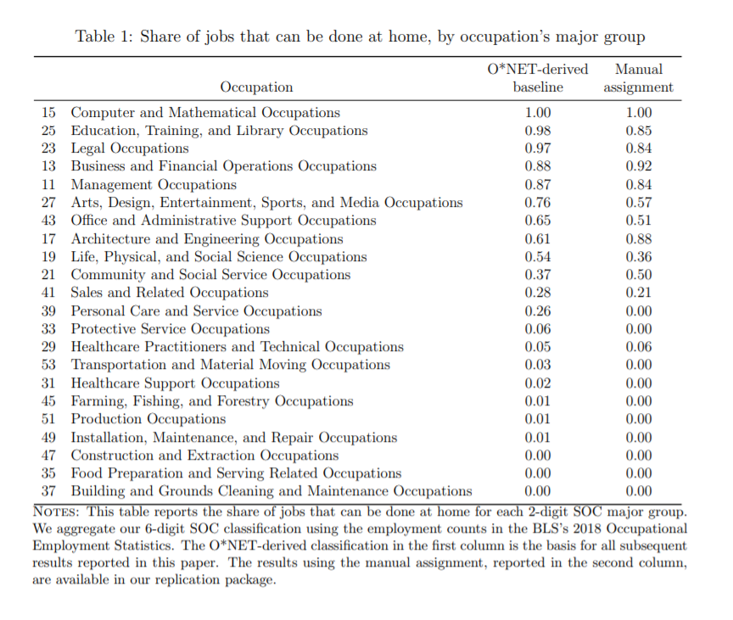

A more recent study was published in May 2020, titled “How does Working from Home Affect Developer Productivity? – A Case Study of Baidu During the COVID-19 Pandemic”, authored by researchers from Zhejiang University, Monash University, and Baidu Inc. This study is by far the most significant, as it specifically concerns software developers. For context, Baidu is a large Chinese Internet services and technology company **(source).** Productivity metrics measured in the study include commits to version control software, code reviews, and software builds. The researchers conducted their study with data gathered by Baidu on the day-to-day behavior of developers **(source)**. They also surveyed developers on how they felt about the impacts of work-from-home. Overall, the study suggested mixed results on the effects of work-from-home on worker productivity, varying depending on certain other characteristics. Factors that played into the results included home environment, communications rituals, and personal self-discipline **(source)**.

An important variable to consider for all these analyses is demographics, particularly for traditionally underrepresented groups like women and people of color. A September 2020 study in *Gender in Management* titled “Covid-19 created a gender gap in perceived work productivity and job satisfaction: implications for dual-career parents working from home” studied this phenomenon in the context of work-from-home. Authors Zhiyu Feng and Krishna Savani theorized that the emergency transition to work-from-home could have a negative impact on women, as responsibilities like caring for children and maintaining the home take precedence over career **(source)**. Conducted between April and May 2020, researchers surveyed several dozen US households with two romantic partners working full-time. Findings indicated that, while the amount of time spent on housework rose for both genders, women surveyed reported longer hours spent on these matters. Additional survey questions concerned work satisfaction and perceived productivity **(source)**. Results of the study indicated that, without childcare, dual-career household women reported less productivity and less satisfaction with work after COVID-19 as compared to before.

In summary, studies indicate that work-from-home offers employees more freedom in terms of geography, personal finance, work-life balance, and much more. Effects on worker productivity are specific to the worker and depend on other variables like team dynamics, home environment, and personal self-discipline. Therefore, these important caveats must be considered both by those determining how WFH benefits could be structured, and by workers themselves thinking about taking advantage of the accommodations. Extra care should be given to specific demographics of workers, such as those newer to the company or married with children. Workers with less experience may find themselves lacking in connection and assistance with onboarding if remote as compared to in-office. Additionally, women may find themselves burdened with “second shift” style responsibilities without access to additional accommodations like childcare services.

**Analysis of Health Impacts**

Another concern for remote workers and employers, especially with a global pandemic, has been worker health - both physical and mental. A report from the Integrated Benefits Institute in 2018 found that poor worker health could be costing businesses up to $530 billion/year **(source)**. Additional costs could come in the form of liability or increased occupational regulation. Put simply, no amount of productivity benefits will matter if workers face large adverse health effects from prolonged sedentary activity and isolation.

Physical health is the first half of the equation. There is a growing body of research discussing the negative impacts of prolonged sitting. A 2012 study in the journal *Diabetes Research and Clinical Practice* found evidence associating prolonged sitting with increased risk of type 2 diabetes and early death **(source)**. The same study recommended deeper integration of societal sedentary tendencies into models of physical and cardiovascular health. An additional 2010 study in *Exercise and Sport Sciences Reviews* found similar results, while also recognizing the phenomenon of the “active couch potato”, where the effects of prolonged sedentary activity are felt, even in relatively active individuals **(source)**. A 2019 study in *The American Journal of Cardiology* examined the effects of sitting not just on the peripheral cardiovascular system (limbs), but also the central cardiovascular system, finding significant impacts on both aspects of cardiovascular health **(source)**.

Thankfully, despite the wealth of academic research around sitting, there is also growing evidence about the effectiveness of sedentary intervention measures. In 2020, the *International Journal of Behavioral Nutrition and Physical Activity* released an umbrella review on the effectiveness of interventions in reducing screen time and sitting time. Reviews and meta-analyses of offices all showed significant success in reducing time spent sitting **(source)**. Time reduction ranged anywhere from 39.6 minutes to 100 minutes per 8-hour workday. Further research demonstrated that environmental change specifically was the most effective means of reduction, incorporating changes such as adjustable-height desks, encouraging moving around and frequent breaks, etc. **(source)**. Furthermore, a 2014 study in *Occupational & Environmental Medicine* found that frequent transitions between sitting and standing reduced back pain in office workers while maintaining productivity **(source)**. Another study in 2012 in *American Journal of Preventive Medicine* found similar results with the introduction of sit-stand desks **(source)**. It is clear to see that investments in these measures can more than offset the deleterious physical impacts of work-from-home.

On the other half of the equation, we have the growing epidemic of mental health. According to the Centers for Disease Control and Prevention (CDC), 18.3% of adults in the United States over the age of 18 reported mental illness in 2016. 71% reported headaches and anxiousness due to life stress **(source)**. COVID-19 has only exacerbated these problems. A study in August 2020 from the CDC showed an increase in anxiety and depression from April to June as compared to the same time period in 2019. Rates of anxiety increased from 8.1% in 2019 to 25.5% in 2020, while depression increased from 6.5% in 2019 to 24.3% in 2020 **(source)**.

Specifically, we must consider how remote work fits into this model, and whether it helps or exacerbates the problem. Mental health challenges for employees results in lost productivity and increased healthcare costs **(source)**. Chidiebere Ogbonnaya at LSE Business Review wrote an article in April 2020 discussing this very subject. In particular, he seemed to observe that while some found the prospect of remote work empowering and energizing, others found it lackluster and a struggle **(source)**. Studying 3200 workers across Britain, he surveyed them for emotions like neuroticism, introversion, conscientiousness, and openness. He also had them describe the nature of their work, how it made them feel, and whether they had worked remotely in the past or during the current pandemic **(source)**. His results suggested that success in a remote work environment can be highly dependent on each individual’s personality profile. Individuals that scored highly in characteristics like introversion and openness to experience found remote work enjoyable and productive. The desire for isolation and independence in the former, and novelty in the latter, made remote work a natural fit **(source)**. For those higher on the neuroticism or lower on the conscientiousness scales however, the results were less kind. In general, people with higher aptitude for worry and/or low organizational skills found remote work to be a more challenging experience **(source)**.

Overall, the variables to be considered here are the same as those concerning worker productivity. If organizations like Cerner are going to adopt remote work initiatives, extra care must be taken to ensure that new remote employees are keeping themselves as safe and healthy as possible. Investments in resources like sit-stand desks and encouraging workers to take frequent breaks can be incredibly successful in preventing injury. Additionally, team members and managers should think carefully about how they work and the personality traits they possess. While working remotely can be beneficial, it may not be for everyone, and that is perfectly acceptable.

**Analysis of Management**

Great modern team leaders must be comfortable in a dynamic and rapidly changing world like ours. Information technology and digital media allows news to spread faster than ever before, impacting consumer perceptions, stock markets, and corporate trends. COVID-19 is the latest wave in that sea of change, forcing team leaders to adapt yet again. The new challenge is running asynchronous teams distributed across the world, rather than locally in-office.

Team leaders from large companies thankfully seem to have risen to this challenge. According to a survey by Upwork Chief Economist Adam Ozimek, many managers - 56% - think that the rapid remote reorganization has gone better than expected **(source)**. Furthermore, the pandemic has only caused the trend of remote work to accelerate. The same survey indicated that 61.9% of managers anticipate more employees going remote in the future, and the rate of growth expected over the next five years has increased from 30% to 65%.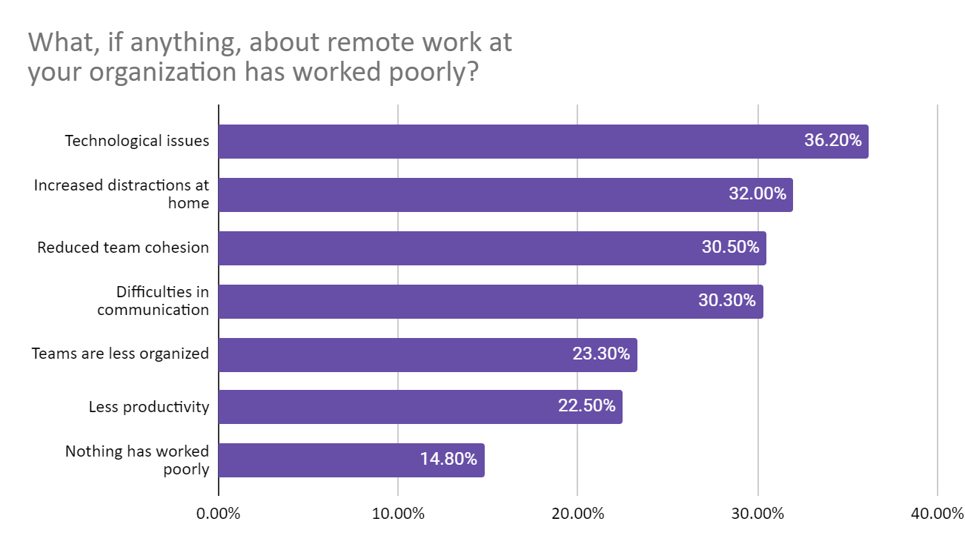Investing in skills for managing remote employees is investing in the future of work. But how can managers - both new and those already in the field - learn these skills?

An article in Harvard Business Review in 2020, titled “A Guide to Managing Your (Newly) Remote Workers”, discussed issues commonly experienced by managers transitioning to working from home, as well as tips for mitigating them **(source)**. One problem discussed is how geographic distance can contribute to organizational distance. Remote employees may think that managers do not understand their problems and experiences, even more so than normal. Other problems may involve difficulty accessing information for newer employees trying to get up to speed. Ways of negating them include regular scheduled check-ins with employees and taking advantage of a variety of communications technologies like email, text, video, and enterprise chat like Slack. Managers must work to build social bonds with their team members and understand the ways they are struggling **(source).**

Adjustment to remote work doesn’t end with the managers closest to an employee, however. All organizational leaders must be prepared and committed to the process. MIT Sloan’s *Three Big Points* podcast offered insight into this in May of 2020. According to the guest featured on the episode, leaders must think of remote work as much more than just working in a different location. Rather, the focus should be on building a more cohesive and conducive employee experience overall **(source)**. Leaders must show vulnerability and be prepared to learn, gathering feedback from workers to better improve their work environment. Like all fast-moving business, the answer is not getting it perfect the first time, but open and transparent iteration. Find the tools and strategies that enable employees to do their best work **(source)**.

Overall, the characteristics of a successful remote team leader are vulnerability, humility, and personability. Team leaders must behave like people first and foremost, rather than tyrants or icons of bureaucratic overhead. They must also be willing to admit mistakes and shortcomings, as that is the only way growth ultimately occurs. Finally, less face-to-face communication means more effort dedicated to forming bonds and a sense of team identity.

**Conclusions**

In the aftermath of the COVID-19 lockdowns and transition to remote work, the executive board for Cerner Corporation requested a report on the potential benefits and downsides of work-from-home accommodations; specifically in the areas of productivity, worker health, and strategies for managers now in charge of hybrid or fully-remote teams.

This report looks at results from previous productivity studies and self-surveys of remote workers - both pre-COVID and those forcefully transitioned due to the pandemic. It also analyzes the growing consensus among medical researchers of the negative health impacts of prolonged sitting, as well as the mental health effects of isolation and working from home. Finally, we also studied reputable business publications for strategies on better managing remote teams.

We conclude that remote work is a viable and effective accommodation for both present and future Cerner Corporation employees. More organizations are expected to offer remote accommodations moving forward, including potential competitors. Remote workers enjoy geographic flexibility, allowing them to choose the area most conducive to their personal, professional, and financial well-being. Elimination of commutes reduces congestion significantly, while saving workers time and energy. Productivity gains can be significant, especially for those in positions matching the profile of work done at Cerner.

Realizing the above gains however depends heavily on the care and precision with which Cerner implements its policies. Physically, proper ergonomics and investment in offerings like sit-stand desks should be encouraged. Frequent breaks should be taken to preserve mobility and cardiovascular health. Mentally, workers should be aware of their psychological tendencies and how a remote environment could affect their work output and satisfaction.

Additionally, other employee demographics should be factored in such as age, gender identity, marital status, children, etc. Younger employees with shorter time at the company may feel lost or disconnected in a remote environment as compared to a physical one. Women may find themselves hampered in terms of career advancement (more so than they already are), while those with children may struggle with the burden of work and additional childcare. Solutions to all of these problems should be baked into a discussion about whether or not remote work is the right choice for a particular employee.

Remote managers must work harder to maintain team cohesion and deadlines on long-term projects. Therefore, managers should be prepared to handle the challenges of asynchronous communication and the physical and organizational distance that remote work can entail.

Improving employee experience should be a primary concern from the top down. Lack of face-to-face communication means a larger time investment in building and maintaining personal bonds with employees to help them feel validated and understood. These can be accomplished by establishing rituals like daily check-in meetings to verify that projects are on track. Remote work does not have to mean social isolation, and managers can encourage social bonds through events and activities that build trust and connection. Various pieces of software like text, email, Slack, Zoom, and Microsoft Teams can be of assistance here.

**Appendix A: United States Unemployment Rate**

This data was acquired from the United States Bureau of Labor Statistics. The original dataset contained data for the year, label for the month and year, value, 12-month net change, and 12-month percent change.

The visualization was constructed simply from the values of the unemployment rate over the period of a year.

Citation for Bureau of Labor Statistics is listed in References,

**Recommendations**

For Cerner, we recommend the following course of action:

* Make optional work-from-home accommodations available for software engineers, IT support, and HR personnel.
* Offer remote employees ergonomic options like sit-stand desks, and encourage short breaks every 30 minutes.
* Offer childcare benefits for employees with young children.
* Train managers in handling remote teams by encouraging regular meetings with employees working from home, and fostering a culture of open communication and care for worker experience

**References**

Larson, B. Z., Vroman S. R., & Makarius E. E. (2020). A guide to managing your (newly) remote workers. *Harvard Business Review*, *18*, <https://hbr.org/2020/03/a-guide-to-managing-your-newly-remote-workers>

Choudhury, P., Foroughi, C., & Larson, B. Z. (2020). Work-from-anywhere: the productivity effects of geographic flexibility. *Proceedings - Academy of Management, 2020*(1), 21199. <https://doi.org/10.5465/AMBPP.2020.225>

Nguyen, P., Le, L. K-D., Nguyen, D., Gao, L., Dunstan, D. W., & Moodie, M. (2020). The effectiveness of sedentary behaviour interventions on sitting time and screen time in children and adults: an umbrella review of systematic reviews. *International Journal of Behavioral Nutrition and Physical Activity*, *17*(1), <https://doi.org/10.1186/s12966-020-01009-3>

Bloom, N., Liang, J., Roberts, J., & Ying, Z. J. (2015). Does working from home work? Evidence from a Chinese experiment. *The Quarterly Journal of Economics, 130*(1), 165-218. <https://doi.org/10.1093/qje/qju032>

Ozimek, A. (2020). The future of remote work. *SSRN Electronic Journal*. <https://dx.doi.org/10.2139/ssrn.3638597>

Feng, Z., & Savani K. (2020). Covid-19 created a gender gap in perceived work productivity and job satisfaction: implications for dual-career parents working from home. *Gender in Management*, Advance online publication. <https://doi.org/10.1108/GM-07-2020-0202>

Credeur, D. P., Miller, S. M., Jones, R., Stoner, L., Dolbow, D. R., Fryer, S. M., Stone, K., & McCoy, S. M. (2019). Impact of prolonged sitting on peripheral and central vascular health. *The American Journal of Cardiology*, *123*(2), 260-266. <https://doi.org/10.1016/j.amjcard.2018.10.014>

Ogbonnaya, C. (2020). Remote working is good for mental health… but for whom and at what cost?. *LSE Business Review*, <https://blogs.lse.ac.uk/businessreview/2020/04/24/remote-working-is-good-for-mental-health-but-for-whom-and-at-what-cost/>

Dunstan, D. W., Howard, B., Healy, G. N., & Owen, N. (2012). Too much sitting - a health hazard. *Diabetes Research and Clinical Practice, 97*(3), 368-376. <https://dx.doi.org/10.1016/j.diabres.2012.05.020>

Baudot, L., & Kelly, K. (2020). A survey of perceptions of remote work and work productivity in the United States during the COVID-19 shutdown. *SSRN Electronic Journal*. <https://dx.doi.org/10.2139/ssrn.3646406>

Michelman, P. (Host). (2020, May 26). Making remote work work [Audio podcast episode]. In *Three Big Points*. MIT Sloan Management Review. <https://sloanreview.mit.edu/audio/making-remote-work-work/>